Global Payroll Services Portal
User Guide

The Global Payroll Services Portal can be used to raise new payroll related inquiries or requests, and to track the status of these once raised.
This user guide has been produced to help users navigate the Global Payroll Services Portal. This document contains instructions as well as some tips to improve the experience and understanding of the Portal.
Content:
1. Global Payroll Services Portal – Homepage 3
2. Raising a New Ticket 4
3. Status & Updates on Existing Tickets 6
4. Providing Additional Information for an Existing Ticket 8
5. Delegating Tickets 9
6. Further Information and Support 10
7. Tips 11

1. Global Payroll Services Portal – Homepage
To begin, access the Global Payroll Services Portal via the following URL:
https://onefinance.microsoftcrmportals.com/

You will arrive at the Customer Support landing page, proceed by clicking on “One Payroll”.

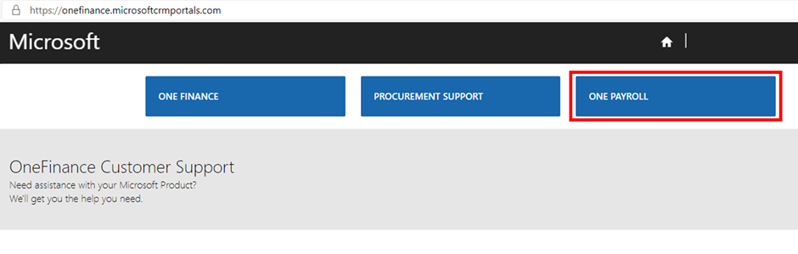

After selecting One Payroll, you will arrive at the Global Payroll Services Portal homepage. This page describes the features available on the Portal, as well as guidance on where to go for further information.
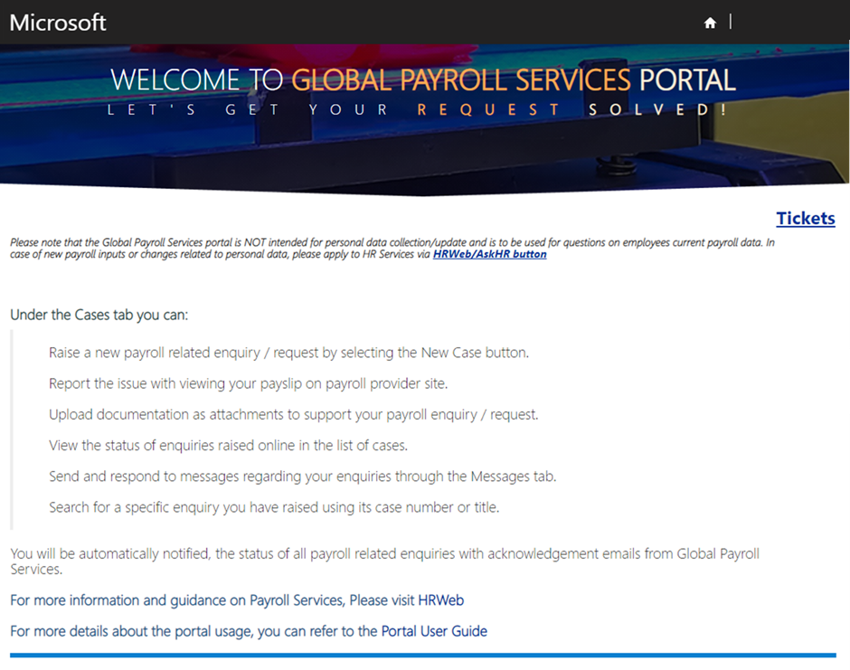

2. Raising a New Ticket
To raise a new payroll related inquiries or request, click on the ‘Tickets’ option.
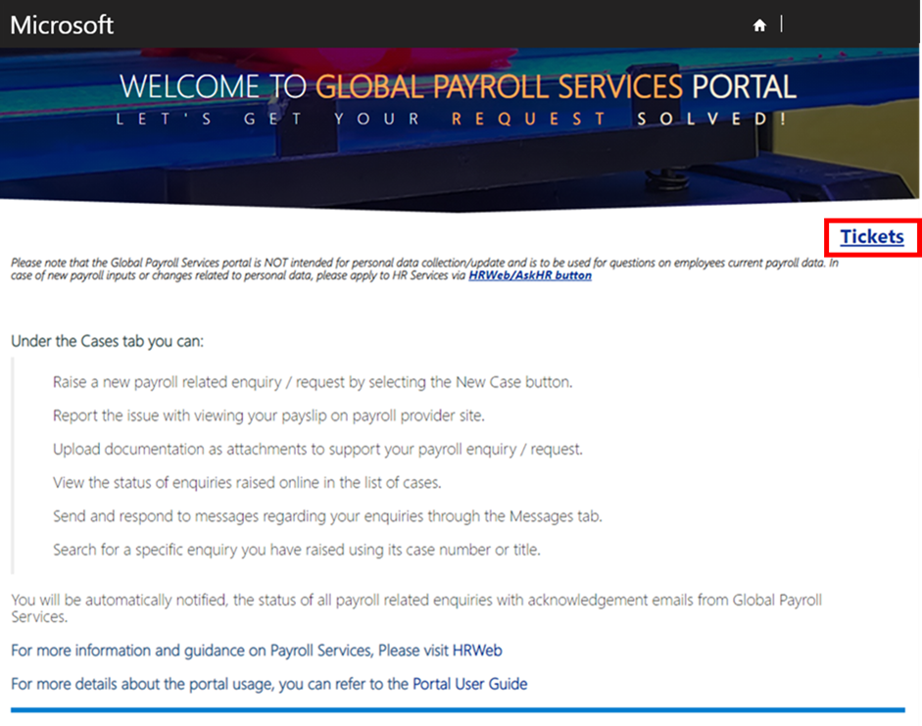

To proceed with creating a new ticket, click on the ‘New Ticket’ button.
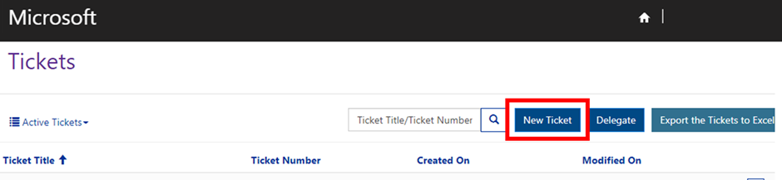

This will take you to the new ticket form, where you can enter the details of your inquiry or request as shown below:
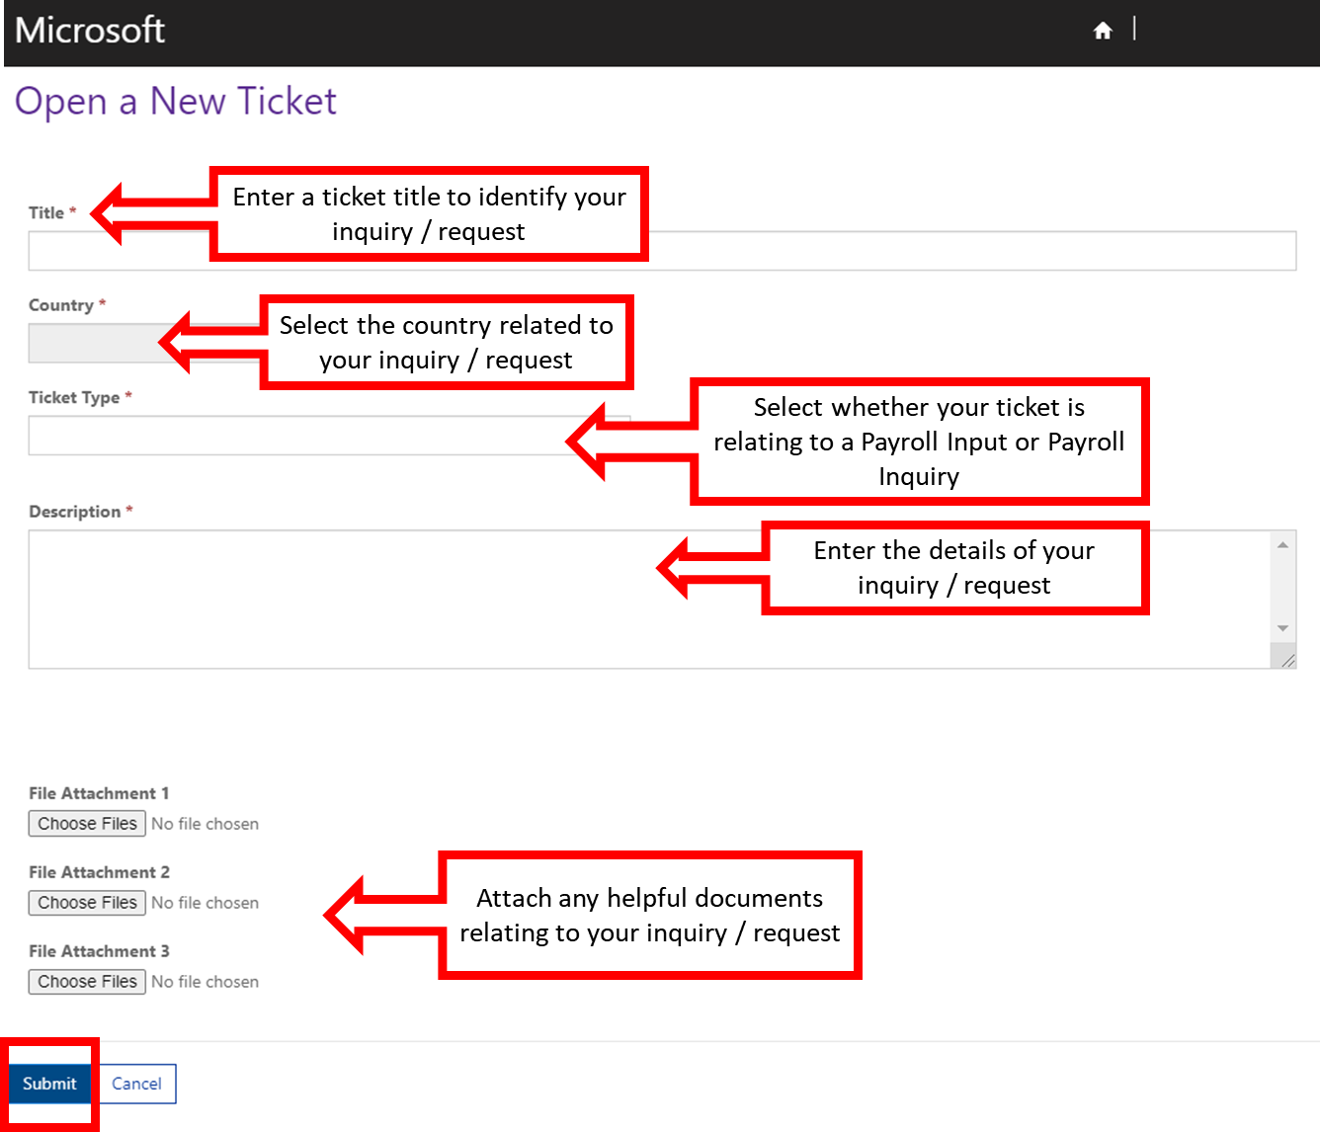
It is important to provide sufficient detail of your inquiry or request within the entry form, as this will help the Global Payroll Services team to process your ticket efficiently.
You will need to either select Payroll Inquiry or Payroll Input for the ticket type:
- Payroll Inquiry: Question, queries, concerns or data request raised by employee, employee manager, HR, finance, third party, or vendor.
- Payroll Input: Any input received from employee, employee manager, HR, third party, or vendor, which needs to be processed in the payroll.
If you have any documentation to support your case, you can provide this as an attachment to the ticket. This can help to give further details of your case to the Global Payroll Services team, without having to re-type lengthy descriptions within the new ticket form.
You can upload multiple documents from your computer, either as individual attachments or create a zip file to share multiple documents together as a single attachment.
When you have provided all details within the form, click on the ‘Submit’ button to create the ticket and send your inquiry/request to Global Payroll Services.
Note: If you are unable to submit the ticket or experience technical issues with the Global Payroll Services Portal, please contact the CCRM Support Team via email: ccrmsupp@microsoft.com

3. Status & Updates on Existing Tickets
After your ticket has been created, you will be sent an automatic email with acknowledgment that your ticket has successfully been created and is now with the Global Payroll Services team. This automatic email will include the ticket number assigned to your ticket, and highlights that you can view the status of your ticket through the Global Payroll Services Portal at any time.
To view the status of all inquiries and requests you have raised, click on ‘Tickets’ option on the Global Payroll Services Portal homepage.
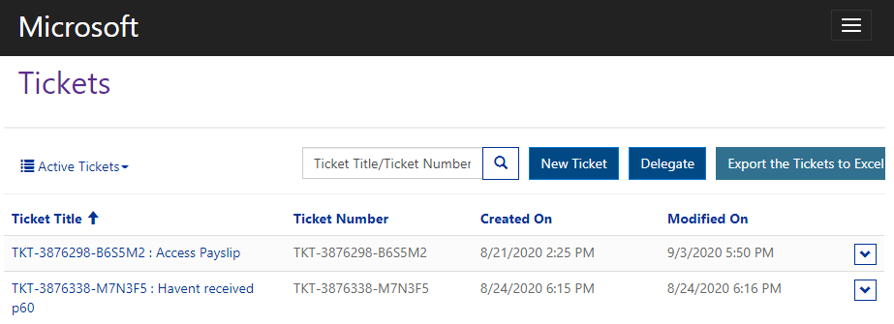

When viewing the Tickets overview page, you can use the search tool to search for a particular ticket using the Ticket Number or Ticket Title.

Please note when searching for a ticket using the ticket title, you will need to use the exact title name, or to search using a partial title name you will need to use the asterisk (*) wildcard character. Use of the wildcard allows for any text before or after a particular word/phrase.

For example, if you wanted to find all tickets with “Payslip access” in the title, you would use a wildcard before and after such as “*Payslip access*”:

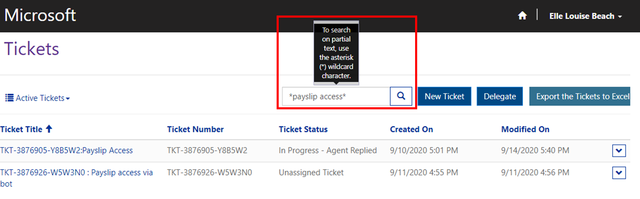

Alternatively, you can use the filter menu to view all inquiries with a particular status – for example to view only active, closed, or delegated tickets.

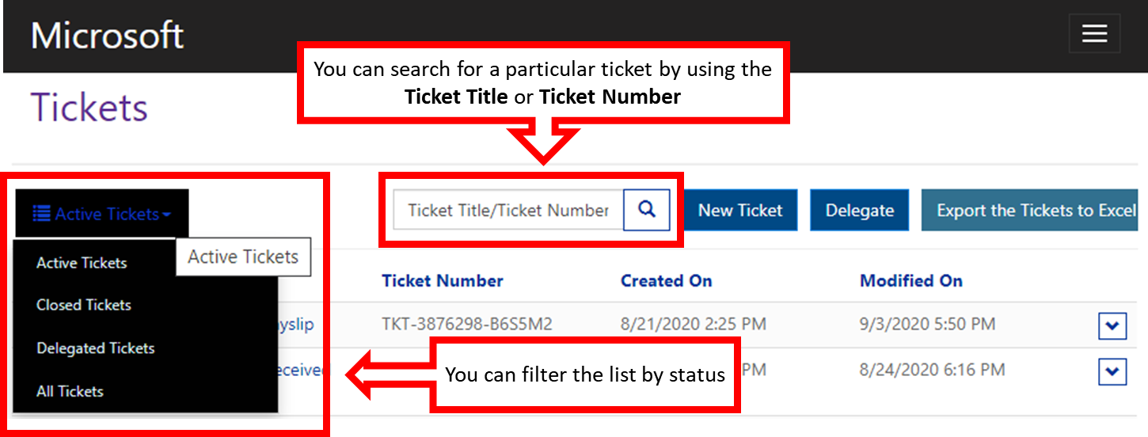
Remember to check under ‘Closed Tickets’ in the drop-down menu if you do not immediately see the ticket you are searching for.
To view more details on the status of a particular ticket, click on the individual Ticket Title as highlighted below. Please note that tickets will only be visible for up to one year.
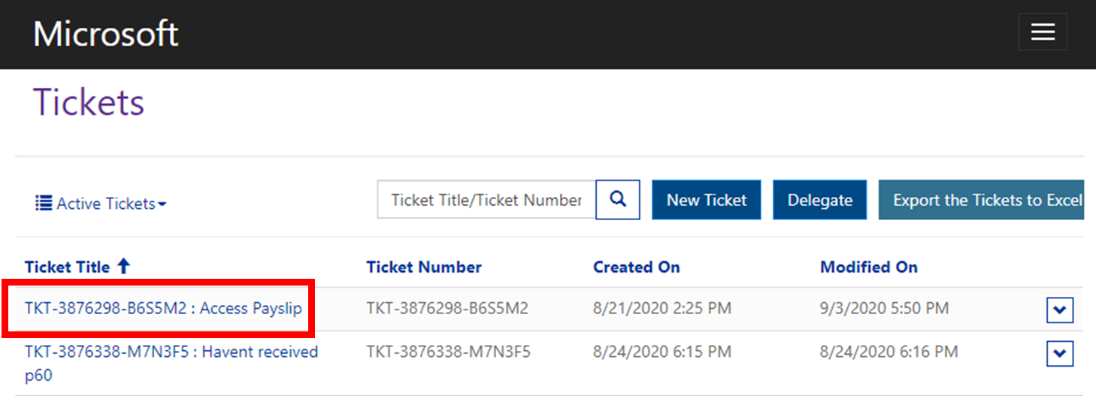

4. Providing Additional Information for an Existing Ticket
Global Payroll Services will contact you to request more information if further details are required regarding your ticket. In this instance, you will receive an email notification that there is a message waiting for you in the Global Payroll Services Portal.
Follow the link in your email notification, or navigate to the relevant ticket on the Global Payroll Services Portal by clicking on the ‘Tickets’ option on the Global Payroll Services Portal homepage, and then select the ticket you wish to view.
The Ticket Details view includes all messages and attachments related to the case, as shown below.
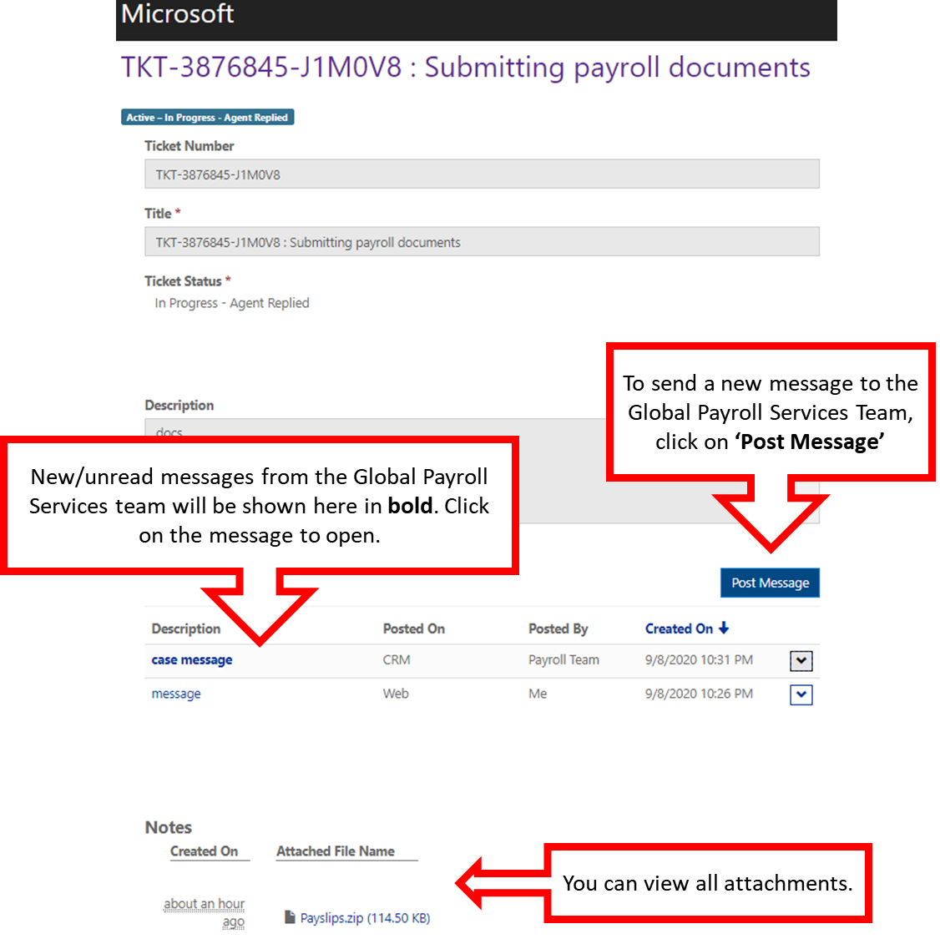
Please note that messages and attachments can only be added to open tickets, i.e. until the ticket status is marked as ‘Problem Solved’.

5. Delegating Tickets
The following guidance is predominantly for HR Specialists and does not directly impact other users.
If you want to give others visibility to some of your tickets, you can do so by delegating 1-5 of your tickets via the ‘Delegate’ button the Ticket overview screen as shown below.
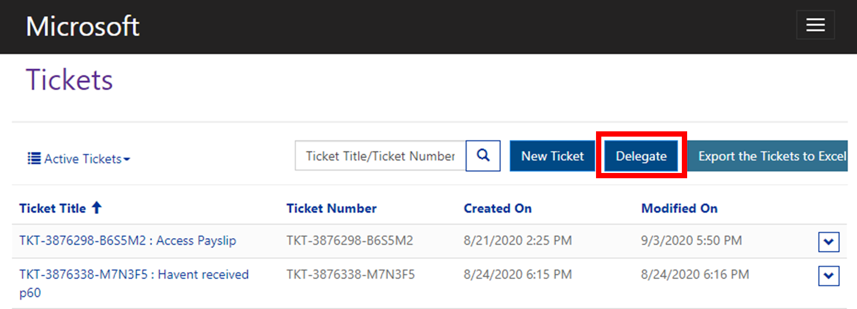

When on the delegate view, follow the below steps –
- Select the tickets you wish to make available to others
- Enter the full email address of the person who you wish to delegate your ticket to
- Confirm by clicking on OK

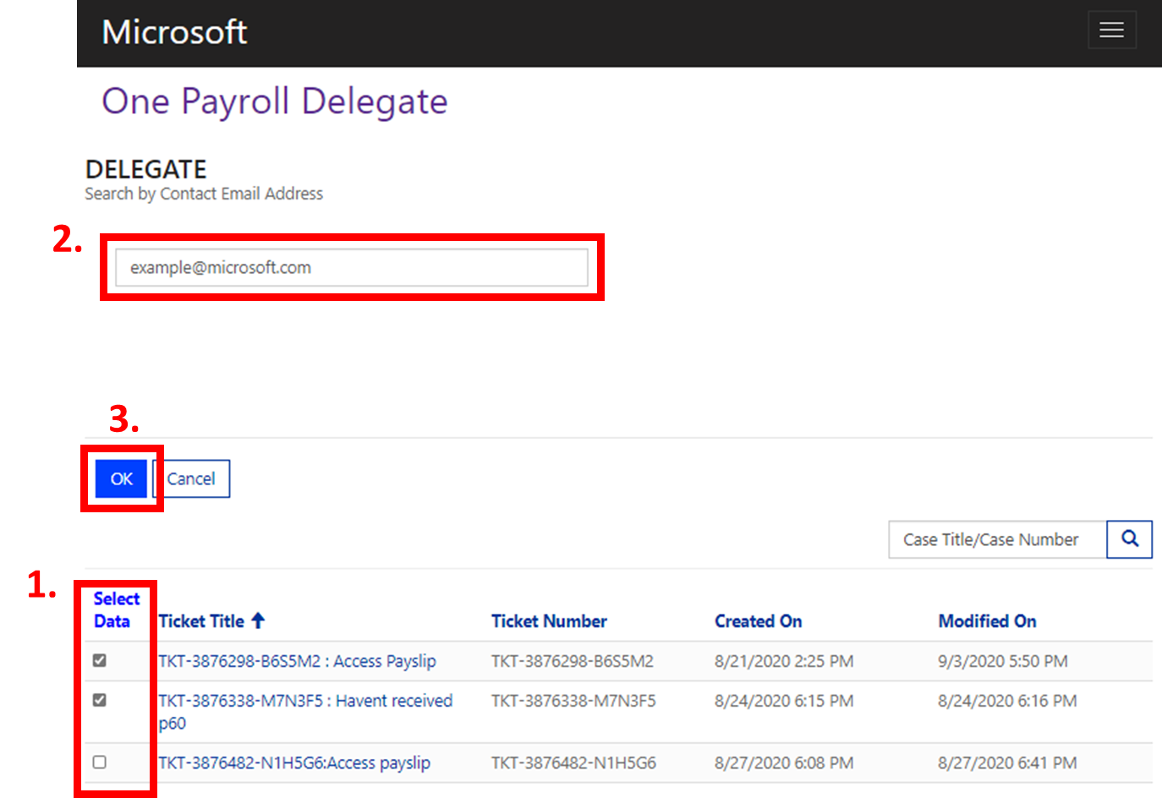
After you have delegated a ticket, you can view the ticket by changing your ticket view on the portal to “All Tickets”. Within this view, you can see the details of all your tickets – including ones that have been delegated.
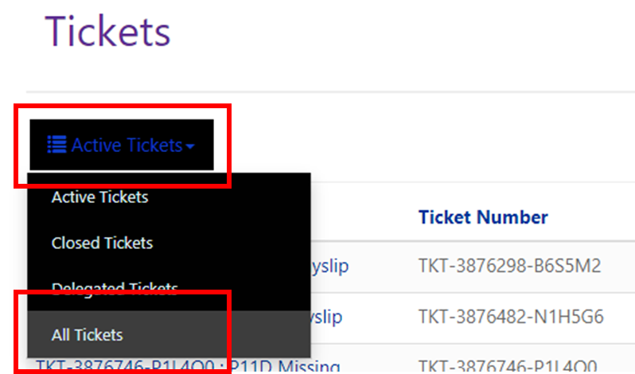
If a ticket has been delegated to you, you can view these tickets via the “Delegated Tickets” view.
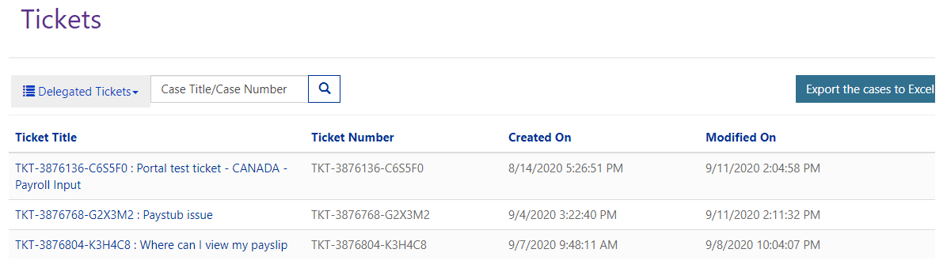
The functionality to revert a delegation of the ticket will be implemented at a later date.

6. Further Information and Support
For more information and guidance on payroll services, including how to escalate an inquiry, please visit the HR Web: http://hrweb/Pages/Defult.aspx
If you are experiencing issues when trying to access your payslip or the Payroll Provider Self-Service Portal, please login to the Global Payroll Services Portal and create a new ticket for the payroll team to investigate.
If you are unable to submit the ticket or experience technical issues with the Global Payroll Services Portal, please contact the CCRM Support Team via email: ccrmsupp@microsoft.com

7. Tips
- If you experience any issues when using the portal, such as a ticket not being listed after you have created one, please log out of the portal, close the window, and reopen the window to log back in. This should resolve your issue.

- When you receive an automated email to say that a ticket has been created or an update has been provided, after clicking on the link to the ticket within the email, if you see the below error message you will need to log-in to see the ticket:
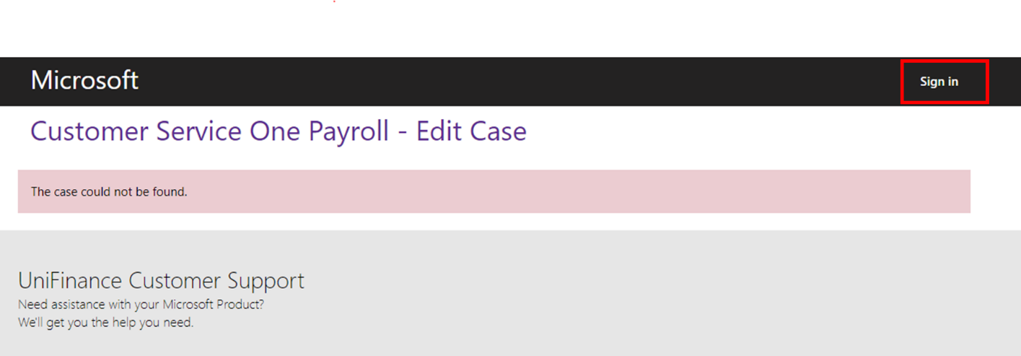
- When using the portal, if you’re viewing details of a particular ticket and you use the back button within the browser, you should return back to the previous ‘All Ticket’ view. However, if you click on the home button at any point, you will be returned to the Customer Support landing page, where you’ll need to click on “One Payroll” to return to the Global Payroll Services Portal.
